Module 9 — JSON Loading & Querying
52. SnowSQL command to upload JSON files into a stage
Command:
PUT ‘file://c:/Users/sarav/Downloads/json_ass1.json’ @stage_ass1;
Meaning:
• PUT = upload file from local computer.
• Local file path = C:/Uers/sarav/Downloads/json_ass1.json
• @stage_ass1 = internal Snowflake stage.
This uploads your JSON file into Snowflake storage.
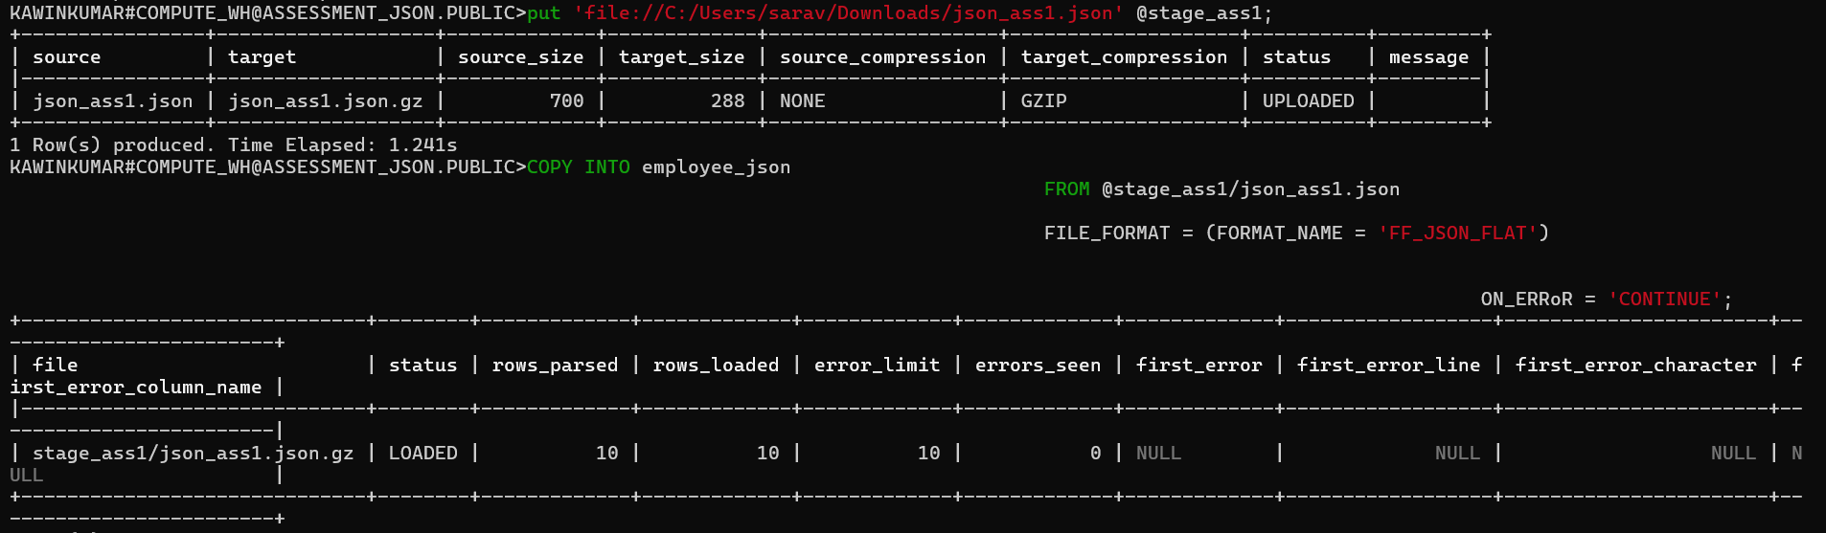
53. COPY command to load JSON into a table1
Command:
CREATE TABLE EMPLOYEES_JSON ( raw VARIANT );
Meaning:
Creates a table with a single JSON column (VARIANT).
COPY command:
COPY INTO EMPLOYEES_JSON
FROM @stage_ass1/json_ass1.json
FILE_FORMAT = (FORMAT_NAME = 'ff_json_flat');
Meaning:
Loads JSON data from stage @stage_ass1/json_ass1 into EMPLOYEES_JSON.
54. Query VARIANT column to extract JSON keys
JSON:
{ "id": 101, "name": "John", "salary": 5000 }
Command:
SELECT
raw:id::int AS id,
raw:name::string AS name,
raw:department::STRING AS department,
raw:salary::int AS salary
FROM EMPLOYEES_JSON;
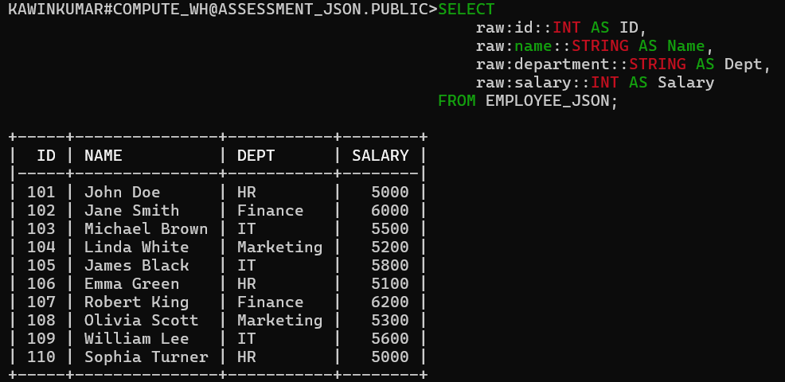
Meaning:
• raw:id extracts value of key id
• ::int casts it to integer
Turns JSON into normal SQL columns.
55. Query array element inside JSON
JSON:
{
"id": 101,
"skills": ["SQL", "Python", "Snowflake"]
}
Command:
SELECT raw:skills[0]::string AS first_skill
FROM EMPLOYEES_JSON;
Meaning:
skills[0] accesses first item of the array → "SQL".
56. Use LATERAL FLATTEN with JSON
JSON:
{
"id": 101,
"projects": [
{"project_name": "P1", "duration": 5},
{"project_name": "P2", "duration": 8}
]
}
Command:
SELECT
emp.value:id::int AS employee_id,
emp.value:name::string AS employee_name,
proj.value:project_name::string AS project_name,
proj.value:duration::int AS duration
FROM EMPLOYEE_PROJECT_JSON,
LATERAL FLATTEN(input => raw) emp,
LATERAL FLATTEN(input => emp.value:projects) proj;
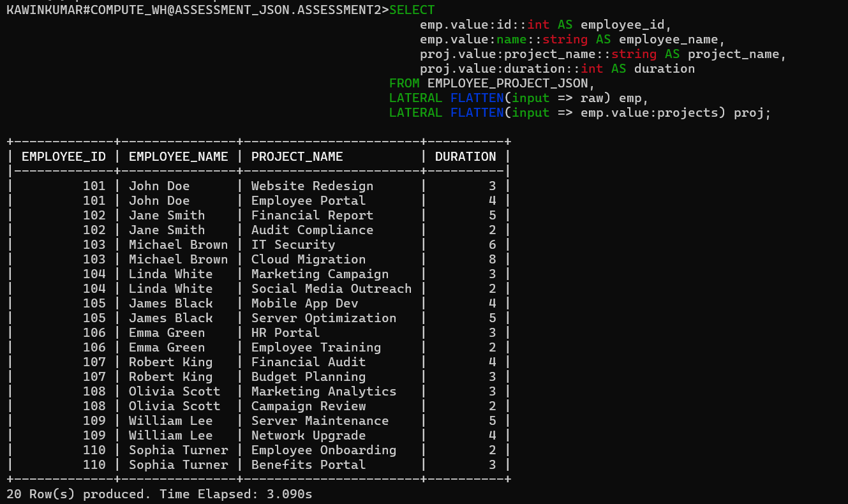
Meaning:
FLATTEN turns array into multiple rows:
101 P1 5
101 P2 8

57. Load multiple JSON files using wildcard
Command:
COPY INTO EMPLOYEES_JSON
FROM @my_json_stage
PATTERN = '.*emp_.*\.json'
FILE_FORMAT = (TYPE = 'JSON');
Meaning:
Loads all JSON files starting with emp_.

58. Validate JSON during load using ON_ERROR
Command:
COPY INTO EMPLOYEES_JSON
FROM @my_json_stage
FILE_FORMAT = (TYPE = 'JSON')
ON_ERROR = 'CONTINUE';
Meaning of ON_ERROR:
• ABORT_STATEMENT – stop if any error occurs
• SKIP_FILE – skip entire file with error
• SKIP_FILE_n – skip after n errors
• CONTINUE – load valid rows, skip bad rows
------------------------------------------------------------------------------------------------------------------------------------------------------------------------------------------------------------------------------------------

Module 10 — XML Loading & Querying

59. Upload XML files using PUT command
Command:
PUT 'file://C:/Users/sarav/Downloads/xml_ass1.xml' @xml_emp;
Meaning:
• PUT uploads a file from your computer to a Snowflake stage.
• 'file://C:/Users/sarav/Downloads/xml_ass1.xml = your local XML file path.
• @ xml_emp = the target internal Snowflake stage where the file is stored.
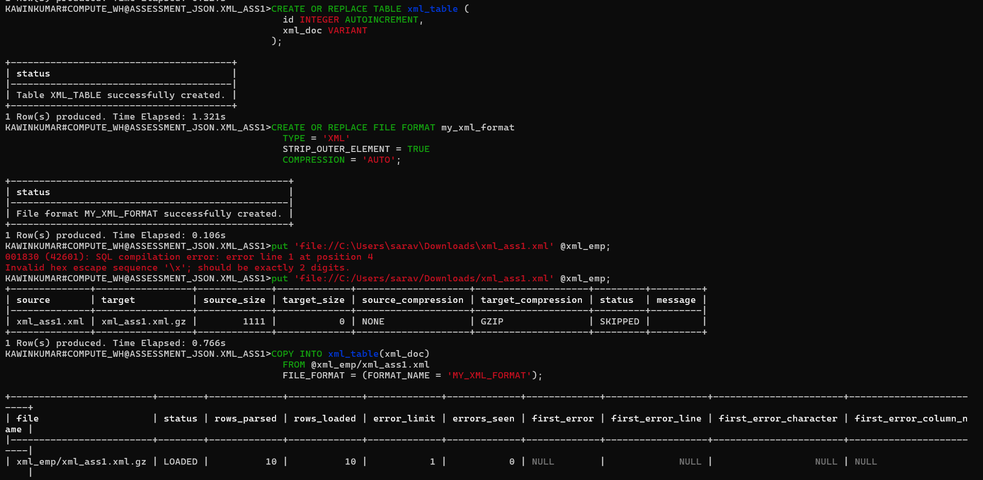

60. Write COPY INTO to load XML into a VARIANT table
Command:
COPY INTO xml_table(xml_doc)
FROM @xml_emp/xml_ass1.xml
FILE_FORMAT = (FORMAT_NAME = 'MY_XML_FORMAT');
Meaning:
• COPY INTO loads data from a stage into a Snowflake table.
• XML_TABLE must have a VARIANT column to store XML.
• FILE_FORMAT = XML tells Snowflake to parse XML content.

61. Query XML attribute values
Command:
SELECT xml_col:"employee"."@id"::int AS EMP_ID FROM XML_TABLE;
Meaning:
• xml_col is a VARIANT column containing XML.
• "@id" extracts an attribute from an XML element.
• ::int converts the value into an integer.
62. Query nested XML elements.

Command:
SELECT
xml_doc:"employee":"details":"name"::string AS EMP_NAME
FROM XML_TABLE;

Meaning:
• xml_doc:"employee":"details":"name" navigates through nested XML structure.
• Extracts <name> inside <details> inside <employee>.
• ::string converts the extracted XML value into a string.
• Used when XML contains multi-level nested elements.

63. Use FLATTEN with XML repeating nodes
Command:
INSERT INTO EMPLOYEES_FINAL (ID, NAME, DEPARTMENT, SALARY)
SELECT
XML_DOC:"@id"::string::int AS ID,
XMLGET(XML_DOC, 'name'):"$"::string AS NAME,
XMLGET(XML_DOC, 'department'):"$"::string AS DEPARTMENT,
XMLGET(XML_DOC, 'salary'):"$"::int AS SALARY
FROM XML_TABLE;
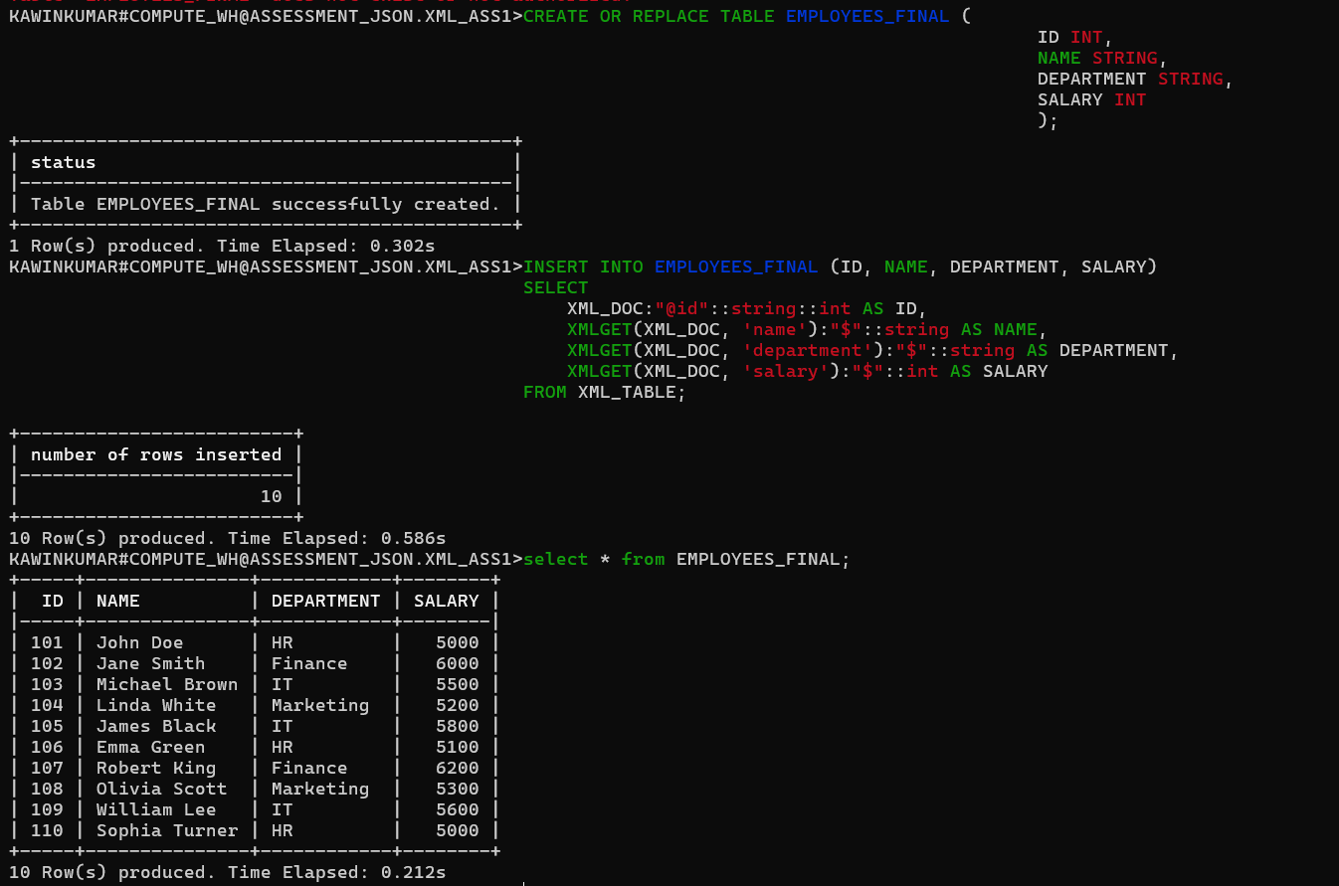
Meaning:
• FLATTEN is required when XML contains repeating elements like <project>.
• LATERAL FLATTEN expands each repeated project into its own row.

64. Load XML files that contain multiple nested elements
Command:
SELECT
emp.value:id::NUMBER AS employee_id,
emp.value:name::STRING AS employee_name,
emp.value:department.dept_id::NUMBER AS department_id,
emp.value:department.dept_name::STRING AS department_name
FROM xml_raw_table,
LATERAL FLATTEN(input => $1:employees.employee) emp;
Meaning:
• $1 = the VARIANT column containing XML data
• employees.employee = path to nested <employee> nodes.
• LATERAL FLATTEN = creates one row per <employee>
•::NUMBER / ::STRING = casts values to readable data types
------------------------------------------------------------------------------------------------------------------------------------------------------------------------------------------------------------------------------------------

Snowflake File Format Commands

65. Create a file format for CSV
Command:
CREATE OR REPLACE FILE FORMAT csv_format
TYPE = 'CSV'
FIELD_DELIMITER = ','
SKIP_HEADER = 1;
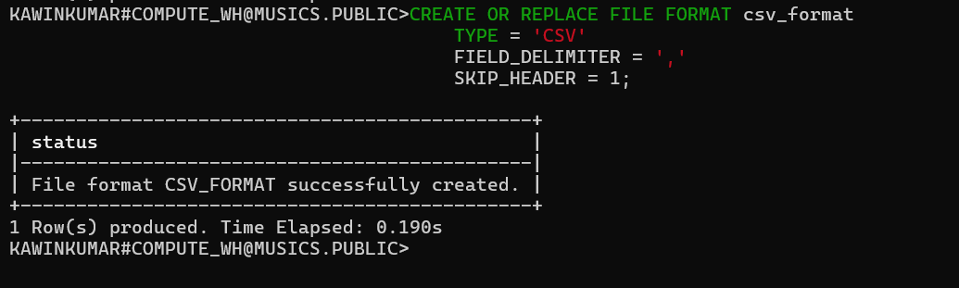
Meaning:
• TYPE='CSV' = File is CSV format.
• FIELD_DELIMITER=',' = Columns separated by comma.
• SKIP_HEADER=1 = Ignore header row.

66. Create a file format for JSON
Command:
CREATE OR REPLACE FILE FORMAT json_format
TYPE = 'JSON';
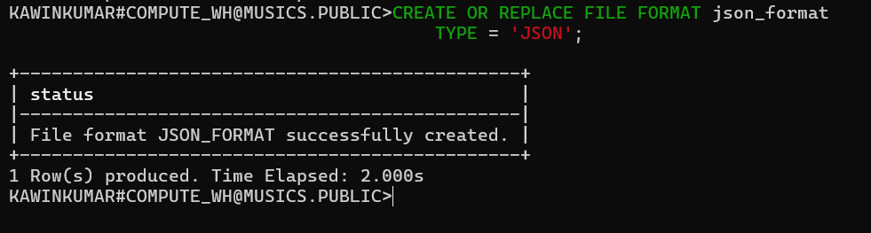
Meaning:
• TYPE='JSON' = File is JSON format.
• Used for nested/semi-structured data.

67. Create a file format for XML
Command:
CREATE OR REPLACE FILE FORMAT xml_format
TYPE = 'XML';
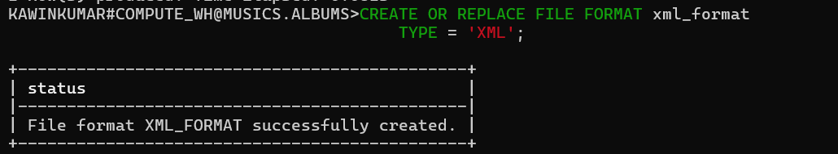
Meaning:
• TYPE='XML' = File contains XML tag-based data.
• Used for hierarchical data.

68. Create a file format with custom delimiter
Command:
CREATE OR REPLACE FILE FORMAT custom_delimiter_format
TYPE = 'CSV'
FIELD_DELIMITER = '|'
SKIP_HEADER = 1;
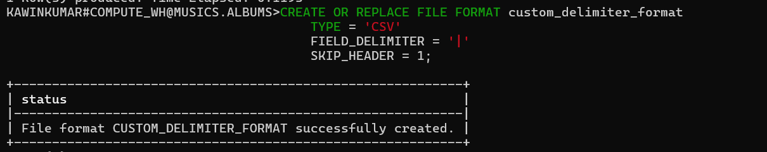
Meaning:
• FIELD_DELIMITER='|' = Columns separated by pipe symbol.
• Used when file uses custom separators.

69. Create a file format for TAB-separated data
Command:
CREATE OR REPLACE FILE FORMAT tsv_format
TYPE = 'CSV'
FIELD_DELIMITER = '\t';
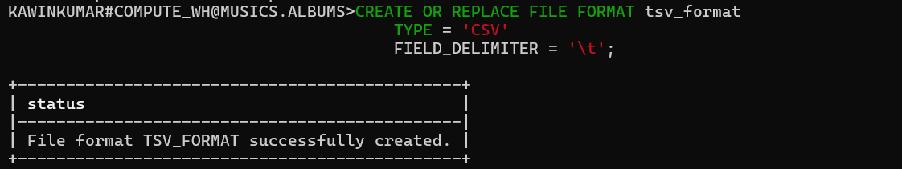
Meaning:
• FIELD_DELIMITER='\t' = Columns separated by TAB.
• Used when data contains commas.

70. Create a file format that ignores quotes
Command:
CREATE OR REPLACE FILE FORMAT ignore_quotes_format
TYPE = 'CSV'
FIELD_DELIMITER = ','
FIELD_OPTIONALLY_ENCLOSED_BY = NONE;
Meaning:
• FIELD_OPTIONALLY_ENCLOSED_BY=NONE = Ignore quotes.
• Useful when quotes are inconsistent.

71. Create a file format that skips blank lines
Command:
CREATE OR REPLACE FILE FORMAT skip_blank_lines_format
TYPE = 'CSV'
FIELD_DELIMITER = ','
SKIP_BLANK_LINES = TRUE;
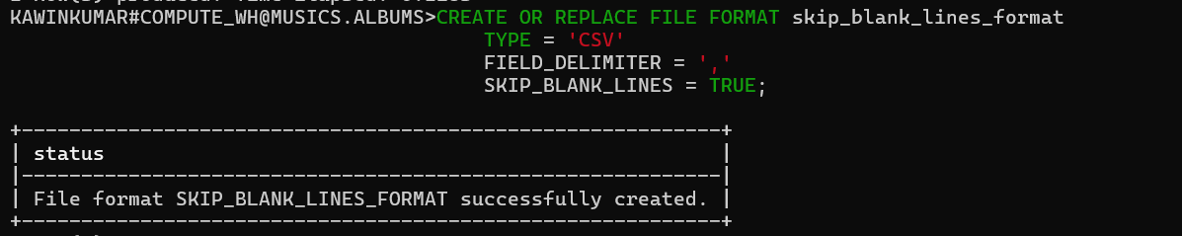
Meaning:
• SKIP_BLANK_LINES=TRUE = Ignore empty rows.
• Prevents load errors from blank lines.

MODULE 12 — WORKING WITH STAGES

72. Create an internal stage using SnowSQL
Command:
CREATE OR REPLACE STAGE my_internal_stage;
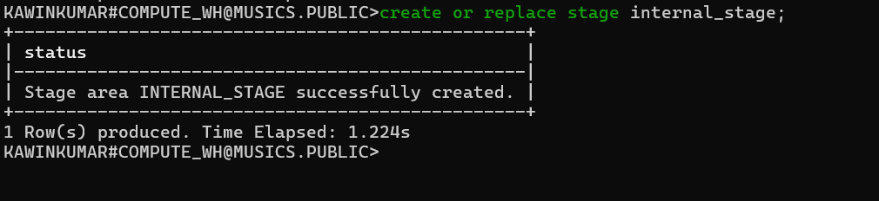
Meaning:
• Creates an internal stage inside Snowflake.
• Used to store files within Snowflake.
• Used along with PUT command to upload local files.

73. Create an external S3 stage
Command:
CREATE OR REPLACE STAGE my_s3_stage
URL='s3://my-bucket/data/'
CREDENTIALS = (AWS_KEY_ID='your_key' AWS_SECRET_KEY='your_secret')
FILE_FORMAT = (TYPE = 'CSV');
Meaning:
• Creates a stage that points to an S3 bucket.
• URL = bucket path where files exist.
• CREDENTIALS = AWS keys to access S3.
• FILE_FORMAT = default file format for loading.

74. List all file formats
Command:
SHOW FILE FORMATS;
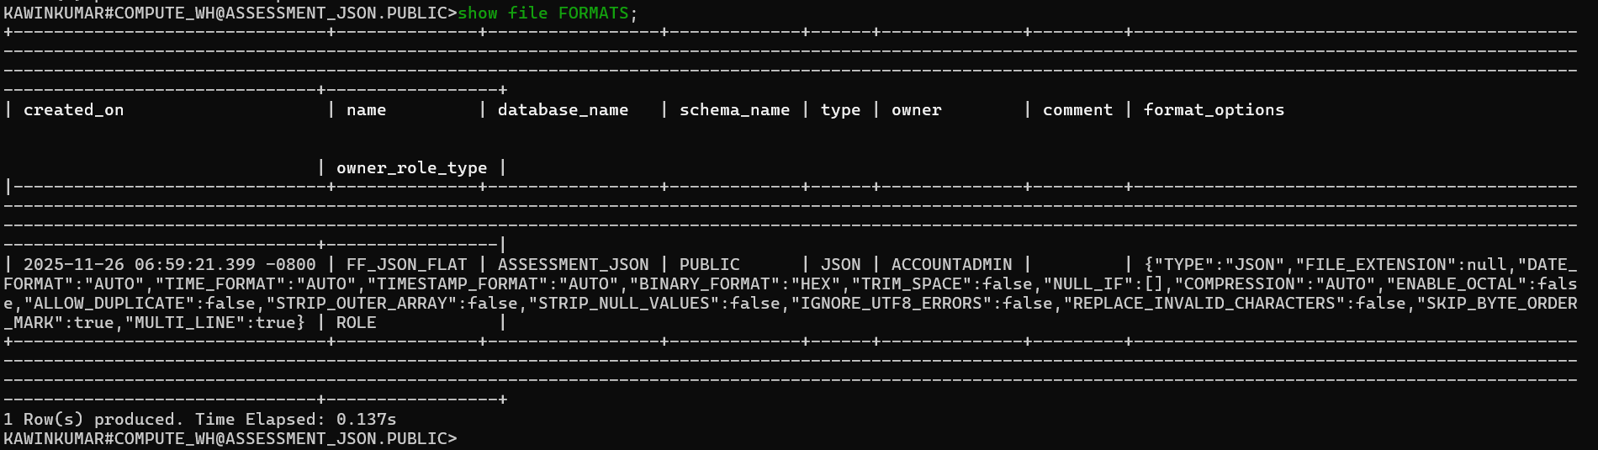
Meaning:
• Shows all file formats created in the Snowflake account.
• Helps verify available formats before loading data.

75. List all stages in a database
Command:
SHOW STAGES;
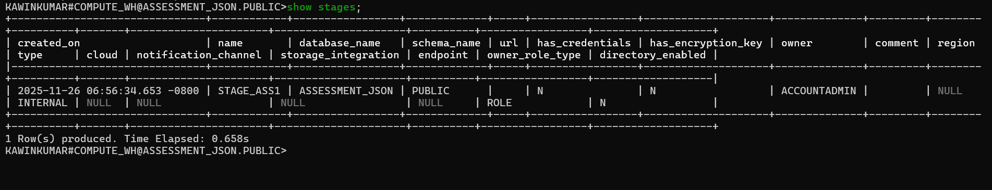
Meaning:
• Lists all internal and external stages.
• Displays type, URL, file format, owner, etc.

76. Refresh an external stage
Command:
ALTER STAGE my_s3_stage REFRESH;
Meaning:
• Forces Snowflake to rescan the S3/Azure/GCS bucket.
• Updates metadata when new files are added or removed.

MODULE 8 — VARIABLES IN SNOWSQL
46. Set a variable inside SnowSQL session.
set dept = 'sales';

select * from dept where dept_name = $dept;
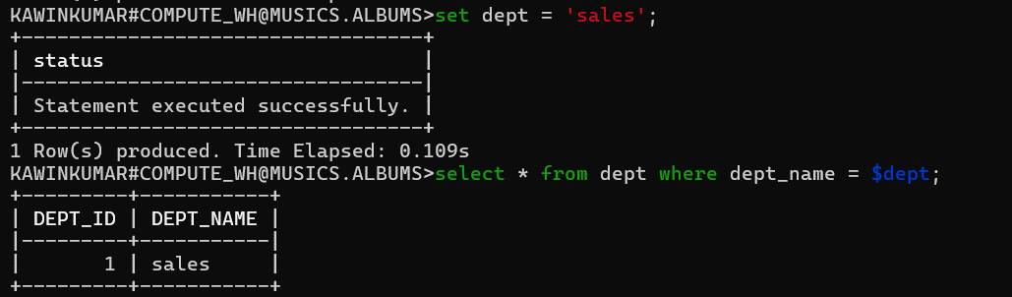
47. Use a SnowSQL variable in a SQL query.
SET tab = 'dept';
SELECT * FROM IDENTIFIER($tab);
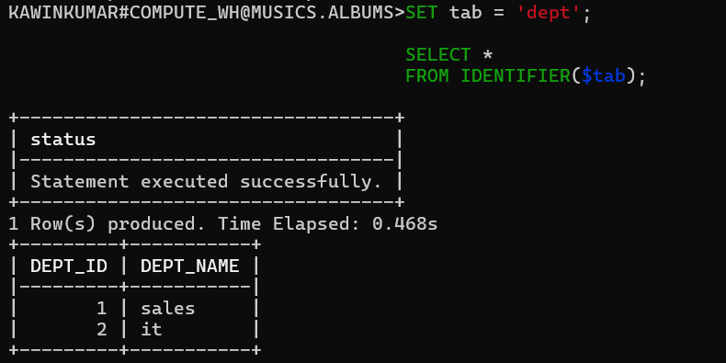
48. Use binding variables (-D var=value) in SnowSQL.
49. Use multiple binding variables in one command.
50. Write a query using a variable for LIMIT.
51. Write a SnowSQL command that overrides a variable in a SQL script.

